Umm Al Khairat location

Umm Alkhirat is a town located in Yassin Locality, East Darfur State (Latitude 11.2126 Longitude 25.4688). approximately 2 hours driving from Eldeain in West direction and its border with Belail locality from West in South Darfur. Prior to the Darfur crisis, Um Alkhirat had approximately 26,000 residents but as a result of instability more than half of the town fled to IDP camps mainly in Gereida Locality. The current population is estimated to be 15,000 of who approximately 6,000 are returnees from IDP camps in East & South Darfur. The main economic activities of the people are agriculture, grazing and trades.
Location of the Hafir
An agreeable site was found about 1 km from Um Alkhirat called Rahad Elfaki, at the bottom of a gentle and wide valley, not yet exploited by other harvesting structures, occupied by eluvia-alluvial deposits. The drainage basin is about 4,000 km2 large. water scarce therefore mask the reality that people in any given location may face. Rain falls in the area for only about four months in the year, so storage of water in aquifers is crucial for water supplies to endure through the dry season, the annual rainfall is meanly 695 mm at Um Alkhirat. Considering a runoff coefficient of 10% it should be possible to store a water volume around 100.000 m3/anno. Deepening the excavation, with regard to the traditional hafir for domestic consumption, and utilizing systems to reduce evaporation it should be possible to extend the presence of water to the dry season, when all other structures usually get dry.

The geology of Um Elkhairat village formed as sedimentary rocks and mud stones, the local construction materials around the area like (stones, gravel, sand, mud and red bricks) are all available around the area and not far from, the other construction material like cement and steel is founded in Eldeain town except the specific types of plastic sheets that needed for bedding/cladding

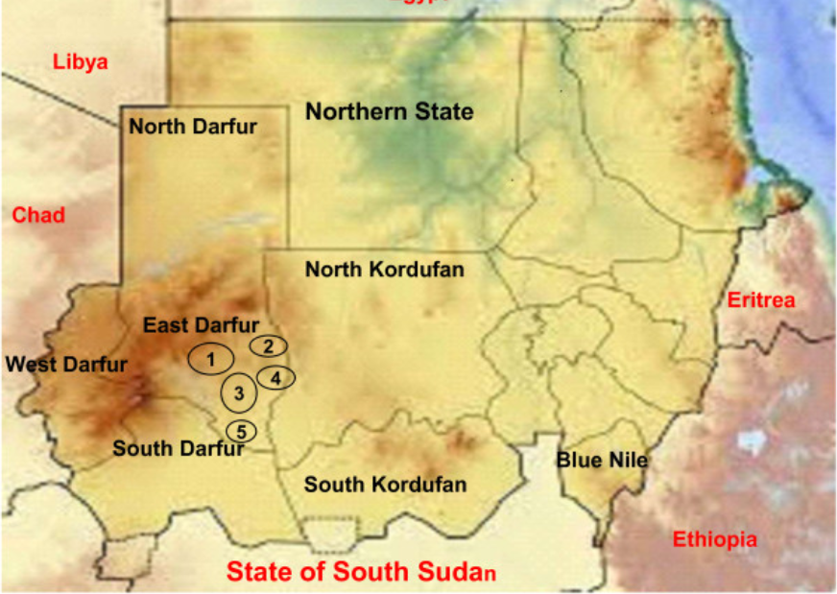
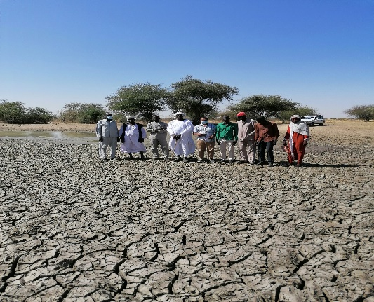
Map-1: The circle No. (5) in the map shows Yassin locality
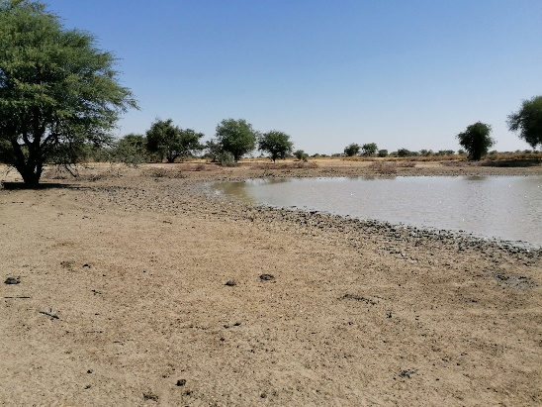

Pictures -1: Shows the Hafir Area and geological feature of the area

